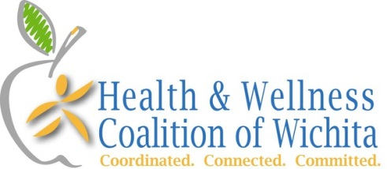
2015 Year in Review
Our vision is for the entire community living a healthy lifestyle. Our mission is to promote physical activity and good nutrition for every generation living in the greater Wichita area through people, programs, and policies.

LEADERSHIP TEAM
The work of the Health & Wellness Coalition is guided by the leadership team that focuses on the long term impact of our work on the health of the community. Much of this work is around establishing practices and policy that advances the mission. The leadership team includes the following members: Adrienne Byrne-Lutz-Sedgwick County Health Department, Kiersten Camp-Textron, Cathy Holdeman-City of Wichita, Mim McKenzie-Greater Wichita YMCA, Janet Miller-City of Wichita Councilwoman, Holly Landon-Wichita Community Foundation, Tim Norton-Sedgwick County Commissioner, Jon Rosell-Medical Society of Sedgwick County, John Schelegel-Member at Large, Dennis Shoenebeck-Greater Wichita YMCA, Becky Tuttle-Health ICT, Jeff Usher-Kansas Health Foundation, Lavonta Williams-City of Wichita Councilwoman.

COMMITTEES
A substantial amount of work has been done by the 5 working committees of the Health & Wellness Coalition. Highlights from each committee this past year include:
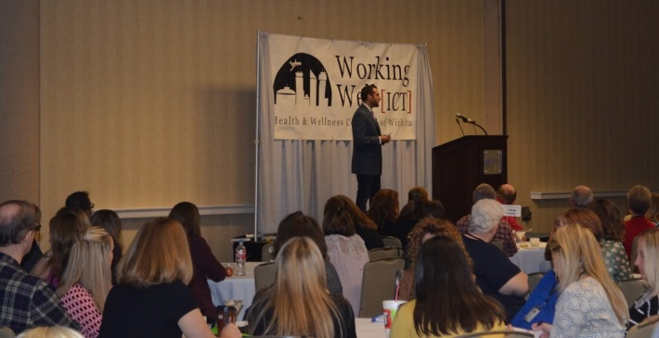
- Working Well Conference Planning Committee: The 12th annual Working Well Conference was held at the Hyatt on August 24 and 25. The preconference included a first-ever WELCOA certification outside the National Summit and webinars. Ryan Picarella, president of WELCOA, presented on How to Create a Comprehensive Stress Management program and was the keynote speaker discussing the Evolution of Wellness. Total participation for the conference was 297, including speakers, vendors, sponsors and committee members.
  - To enable networking for worksite wellness professionals throughout the year, four Think Tank sessions were held. Topics included: February – Building a Culture of Wellness & Well-Being, April – Wellness Vendors-Weeding through the Muck, June – Moving from Programs to Policy, October – Working Well Award Panel.
- Walktober: In collaboration with: Sedgwick County, Derby Health Collaborative, Central Plains Area Agency on Aging, the Greater Wichita YMCA, Safe Kids, Heads Shoe Store and Bike Walk Wichita, “Walk with Me” was the Walktober theme. Over 12,000 copies of the calendar card were distributed through USD 259 and the community with approximately 400 people actively reporting on the new online Health Movement platform.
- Healthy Schools Committee: The purpose of this committee is to actively work to ensure a healthy school environment by advocating for physical activity and healthy eating for students and staff. See next page for the 2015 school awards.
- Healthy Eating Committee: A Healthier Catering Made Easier guide was created and posted to the website to provide at-a-glance guidelines for ordering food at worksites. The theme for Food Day was Pantry Raid with tips to Stock, Swap and Save in your pantry.
- Bike Month Planning Committee: Another collaborative effort, planning for bike month was assisted by the City of Wichita, Bike Walk Wichita, Safe Kids, and the Sedgwick County Health Department. A lengthy list of events were planned and posted to the BikeMonthWichita.org website. The month of activities began with a kick-off movie, “Inspired to Ride”.

COALITION MEETINGS
The Health & Wellness Coalition received a website upgrade in 2015 with a fresh, clean look. The partner member list was also updated for accuracy. Regular meetings occurred this year with the following topics: January – WorkWell KS & Stanford’s Chronic Disease Self-Management Program, March – Sedgwick County Extension Healthy Eating Initiatives, May – Bike to School day volunteering at McLean Elementary, July – SafeKids, September – Communities Supporting Breastfeeding, November – City of Wichita Transit training. A monthly newsletter was sent monthly to over 7,000 people with an average open rate of 18%.

Two new initiatives in this year include the Coalition of Coalitions Protecting and Promoting Public Health and the Food Policy Council. There has also been a growth in the number of bicycle riders and walkers in Wichita. Since 2012, the number of people using bike paths has increased by 45 percent.

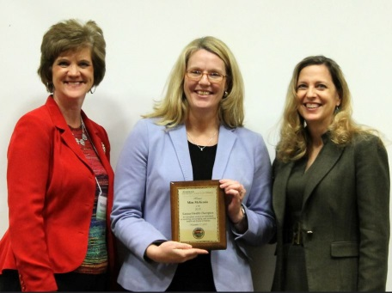
AWARDS
In 2015, there was no shortage of accolades for the Health & Wellness Coalition.
- Mim McKenzie was selected by the Governor’s Council on Fitness to receive the Kansas Health Champion award at the Obesity Summit, resulting in statewide recognition for her work to make the community healthier.
- The City of Wichita was awarded the Kansas Public Health Association Policy Maker of the year.
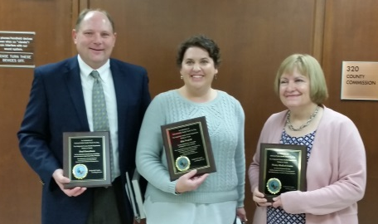
- Kim Neufeld, president of Bike Walk Wichita, and Paul Gunzleman, City of Wichita engineer were selected as National Public Health Thank You Day recipients.
- The 12th annual Working Well Awards were presented at the Working Well Conference. Congratulations to: Derby Recreation Commission (small employer), Royal Caribbean (medium employer) and Via Christi Health (large employer).
- For the 9th year, local schools received $1,000 grants thanks to funding from the Wichita Community Foundation. The schools recognized in 2015 include: Woodland Health and Wellness Magnet Elementary for their family run night, Gammon Elementary for their Girls on the Run program, and St. Catherine of Siena Catholic School for their family cooking night.

The Health & Wellness Coalition is now on Facebook:
